A translator for MIPS to RISC-V
taomiao

Section I. MIPS ISA description

1. instruction formats
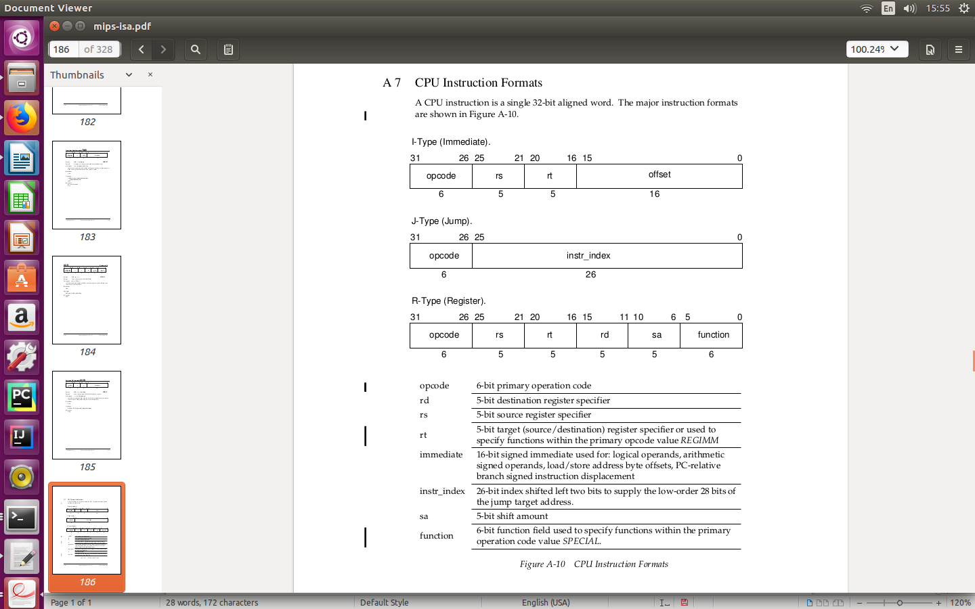
2. instruction encoding
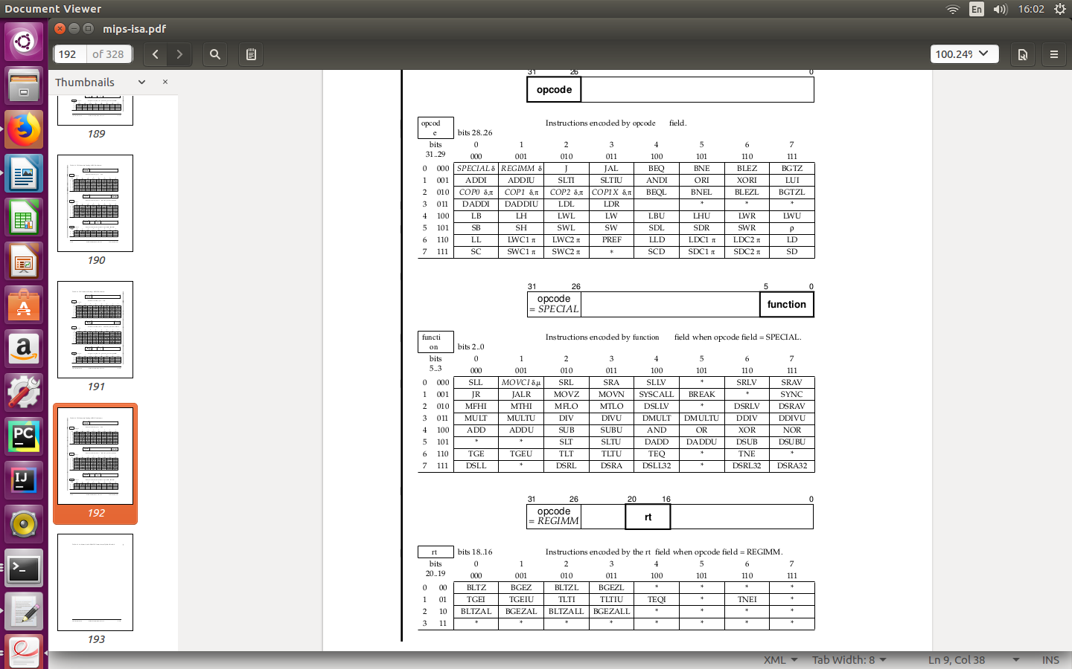
Section II. RISC-V ISA description

1. RISC-V base instruction formats
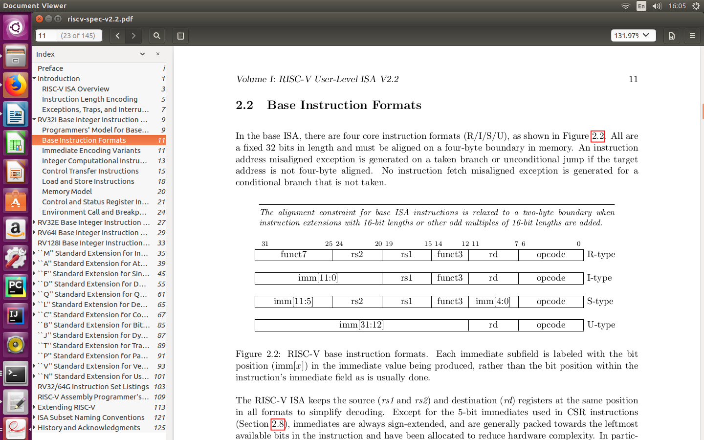
2. RISC-V base instuction encoding

Section III. Relation of MIPS to RISC-V

Section IV. Translator Design

